**High water route – Loop distance 8.09 miles**

**Elevation**

**8 Mile - Approx. 1,200**

**25K – Approx. 2,400**

**50K Approx. 4,800**

* **Start at West Tyson park entrance**
* **Immediate Right turn and head up past bathrooms onto Flint Quarry Trail**
* **Approx. 1.7 miles up to Picnic Table – Turn Right**
* **Continue on trail down to train tracks.**
* **Cross over train tracks to Aid Station #1 – Aid Station is at approx. 2.7 miles**
* **Continue past Aid Station #1 and make Right turn at signs in field.**
* **Follow signs/flags for a loop around field**
* **Loop around field returns to Aid Station #1 at approx. 4.2 miles**
* **Return back over train tracks retracing back up towards picnic table**
* **Follow signs/flags up to picnic table to approx. 5.5 miles**
* **Turn right at picnic table and return on Chubb trail**
* **Follow signs/flags on Chubb trail until returning to upper parking lot**
* **Follow signs/flags on pavement down from upper parking lot to make left turn**
* **Follow pavement to orange cone/flags to turn right up Chinkapin Trail at 7.75 miles**
* **Follow up and down Chinkapin trail (.35 miles) back down to Finish**

**\*\*25K runners will turn right at base of Chinkapin onto Flint Quarry trail and complete 2nd loop and 50K will complete 4 loops. (additional loops slightly shorter since they start at base of Flint Quarry instead of the park entrance)**

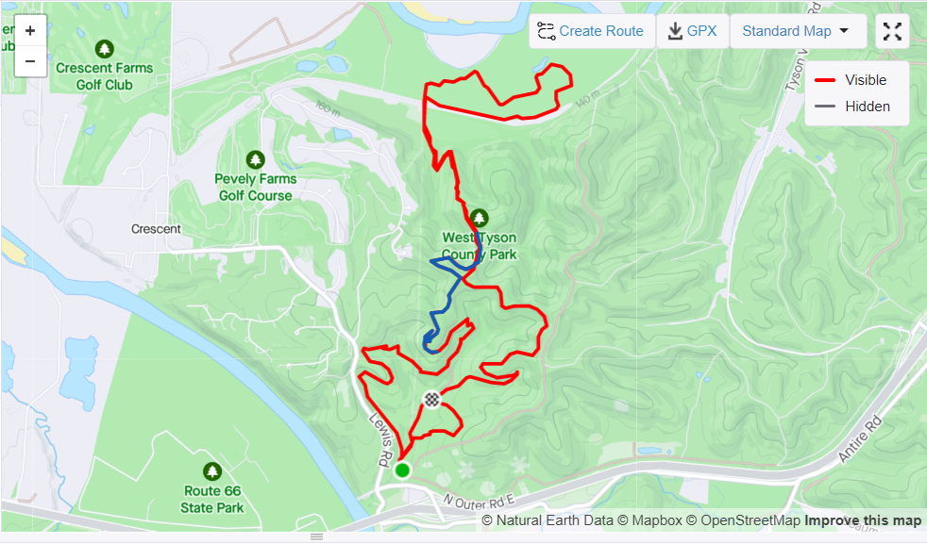

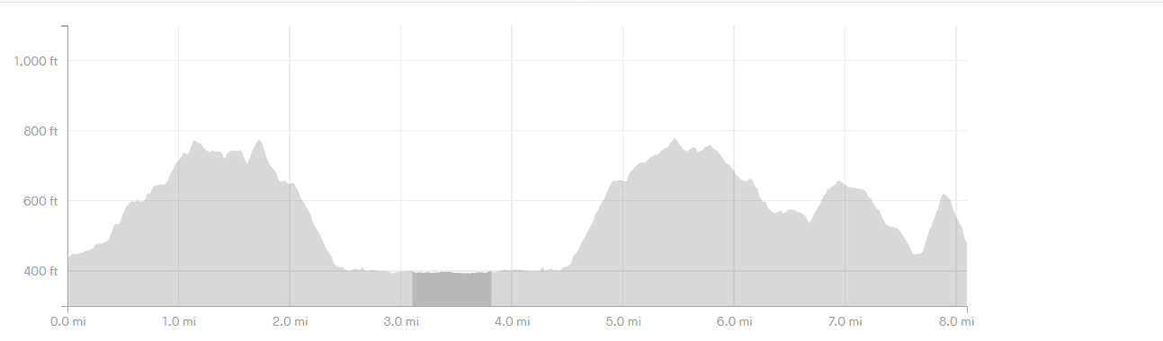

**8-mile Original Route (Low water route)**

**8 M – 1300 feet**

* **Start at West Tyson Park entrance**
* **Follow pavement straight up to entrance to Chubb trail in upper parking lot circle**
* **Follow signs/flags up to picnic table (2.15 miles)**
* **Continue on trail down to train tracks**
* **Cross over train tracks to Aid Station #1 – Aid Station is at approx. 3.1 Miles**
* **Continue past Aid Station #1 follow signs/flags straight along river route**
* **8 MILE ONLY – Turn at orange cone at 3.85miles**
* **Return back to aid station #1 following signs/flags – second stop at Aid Station is approx. 4.5 miles**
* **Cross tracks and return up to Picnic Table at approx. 5.5 miles**
* **Follow signs/flags on Chubb trail until returning to upper parking lot**
* **Follow signs/flags on pavement down from upper parking lot to make left turn**
* **Follow pavement to orange cone/flags to turn right up Chinkapin Trail at 7.75 miles**
* **Follow up and down Chinkapin trail (.35 miles) back down to Finish**

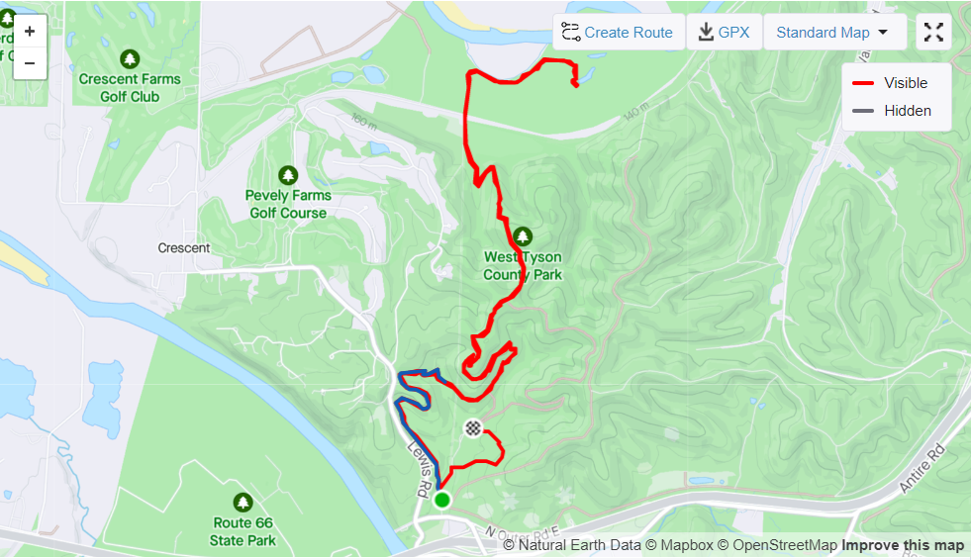

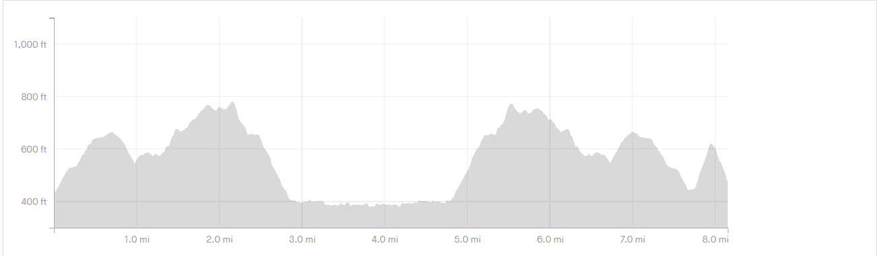

**Original Route – 25K & 50K (Low Water Route)**

**25K – 2000 feet**

**50K – 4000 feet**

* **Start at West Tyson Park entrance**
* **Follow pavement straight up to entrance to Chubb trail in upper parking lot circle**
* **Follow signs/flags up to picnic table (2.15 miles)**
* **Continue on trial down to train tracks**
* **Cross over train tracks to Aid Station #1 – Aid Station is at approx. 3.1 Miles**
* **Continue past Aid Station #1 follow signs/flags straight along river route**
* **IGNORE 8 MILE ONLY – Turn around orange cone at 3.85miles and instead continue on along the river trail**
* **Follow signs/flags along river trail and cross train tracks**
* **Follow fire road towards Lone Elk park**
* **Climb up trail to entrance of Lone Elk park**
* **Cross service road following sign/flags to Turtle Trail**
* **Pass Wild Bird Sanctuary (cross entrance road to continue on trial)**
* **Follow signs to Aid Station #2 (Turn around) at approx. 7.8 miles**
* **Return back to aid station #1 following signs/flags – second stop at Aid Station is approx. 11 miles**
* **Cross tracks and return up to Picnic Table at approx. 12 miles**
* **Follow signs/flags on Chubb trail until returning to upper parking lot**
* **Follow signs/flags on pavement down from upper parking lot to make left turn**
* **Follow pavement to orange cone/flags to turn right up Chinkapin Trail at 15.2 miles**
* **Follow up and down Chinkapin trail (.35 miles) back down to Finish**

**\*\*50K runners will complete a second loop**

(Please note, below map has a small amount of distance on a trail near turnaround added but is pretty accurate for overall trail map)

